Nueces County Emergency Services District #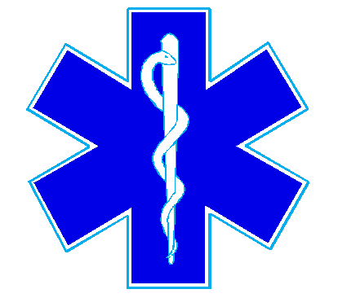4

Bluntzer Fire Department/EMS

5781 FM 666

Robstown, TX 78380

Office (361)387-4066

January 19, 2022

There was not a quorum for the January 19, 2022 meeting.