Nueces County Emergency Services District #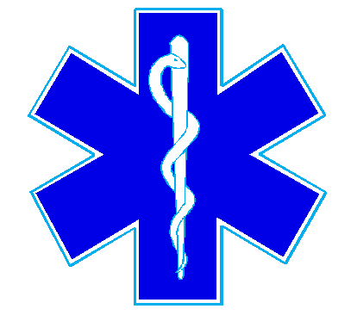4

Bluntzer Fire Department/EMS

5781 FM 666

Robstown, TX 78380

Office (361)387-4066

December 11, 2024

There was not a quorum for the December 11, 2024 meeting.