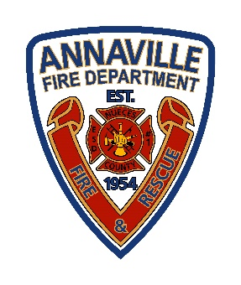
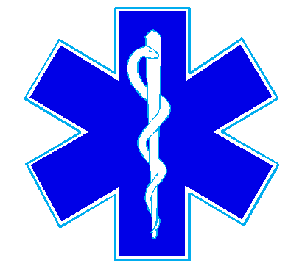
Nueces County Emergency Services District #1
Annaville Fire Department
5241 County Road 73
Robstown, TX 78380 | Office (361)241-1372

Fire Protection for “No Man’s Land” in Nueces County
Some areas of Nueces County currently don’t have dedicated fire or EMS service. These areas, often called “No Man’s Land,” rely on nearby fire departments—like ESDs, Robstown, or Corpus Christi—when available, but coverage is inconsistent.
To provide reliable protection, ESD 1, ESD 3, and ESD 4 residents have petitioned the ESD’s in the unprotected areas to join their district through annexation.

How the Annexation Vote Works
- Residents in the proposed area vote on whether they want to join the ESD.
- Residents already in the ESD vote on whether to accept the new area.
- Both votes must pass for the annexation to happen.
Elections are scheduled for the November ballot.

Why Residents Are Considering Annexation
- Better insurance access: Many homes in unprotected areas have trouble getting insurance or face high premiums.
- Faster emergency response: Joining an ESD ensures a clear, assigned fire and EMS provider.
- Cost vs. benefit: Property taxes for ESD coverage may be less than potential insurance savings.
(Note: ESD membership does not guarantee lower insurance rates; check with your provider.)

Property Tax Facts
- Maximum ESD tax: $0.10 per $100 of property value
  - $100,000 home = $100/year | $500,000 home = $500/year
Joining an ESD helps ensure your home and community have reliable fire and emergency protection.
Fire Chief Michael Clack
Nueces County ESD #1 /Annaville Fire Department
5241 County Road 73 | Robstown, TX 78380
Office (361)241-1372 | chief@annavillefire.com

